10 Cubes System
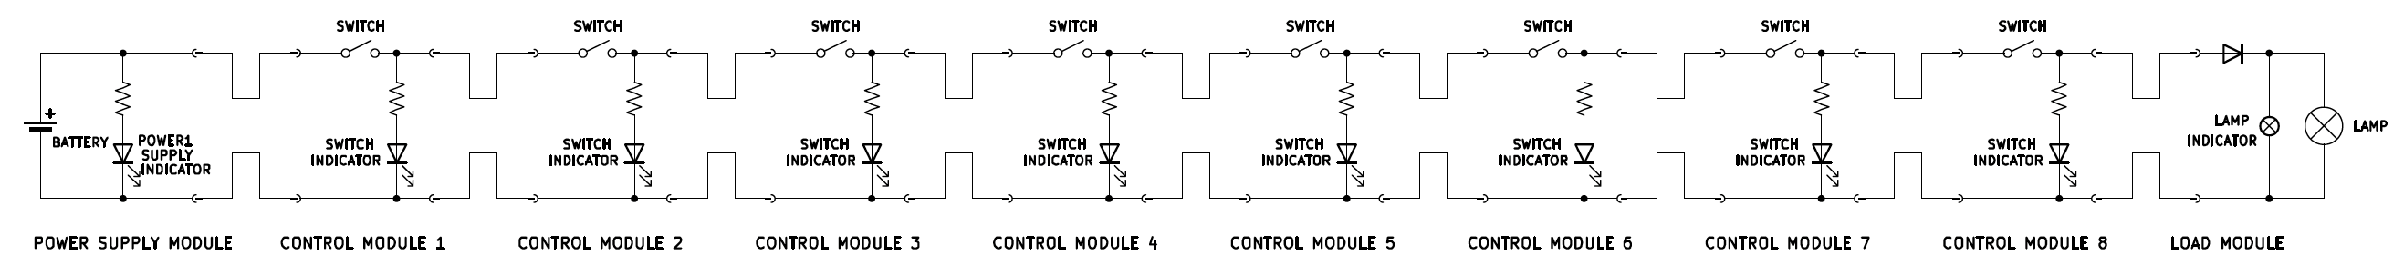



The system has the overall function of operating a load (lamp).

The system is composed of 10 modules connected in series: a power supply module, 8 control modules, and a load module.
Each module is made of an electrical circuit encased in a plastic box.
The modules are connected by unmarked cables: two cables come out of one face of the power supply box and of the load box, four cables come out of two opposite faces of each control module box (two cables per face).
The cables are unmarked and have the same color: one cannot distinguish one from the other just by looking at them.
The cables terminate with fast-connection terminals that can be attached and detached together, allowing for connecting and disconnecting the modules together.
The circuit inside each module can be inspected through a dedicated panel.

Inside the power supply module box, there is a battery case for a 12V lithium battery. On the top face there is a green led, which is inserted in a LED holder (it can be put in and out at will). The LED is in series with a resistor, and the LED and the resistor are connected in parallel with the source, and the LED is oriented so that it will turn on when the 12V source is active and supplied. Of the cables that exit the module, one is connected to the 12V input positive port, the other to the negative port.

The four cables coming out of each control module constitute two connected pairs (so during operations one cable per face will have 12V, the other 0V). One such couple can be opened by a switch, which is encased in the middle of one of the box faces. Connected between the 12V line and the 0V line there is another resistor in series with a red led, which is inserted in a LED holder (it can be put inserted and removed at will) on the top face of the box. The LED is oriented in such a way that when the 12V line is energized and the module switch is on, the LED will turn on. This LED is sometimes called control module indicator or control module LED but is generally called switch indicator.
The control modules are connected in series with each other, and they are numbered from 1 to 8 (control module 1 to control module 8). Control module 1 is connected in series after the power supply module, while control module 8 is connected directly before the load module.

The two cables coming out of the load module are simply connected to the load ports. The lamp itself is encased on the top face of the box. In parallel to the lamp there is a smaller indicator lamp, that is positioned inside the box, and can be seen only by either lifting the box or by opening a small peephole located on of the box faces. Both lamps are not polarized by themselves, however there is a diode located on the 12V line, before both lamps, such that it will allow current to flow only if the 12V and 0V lines are actually energized with 12V and 0V respectively (it will block current if the polarity is switched).

